Rite of Admission Outline (Ritual pp. 11-17)

Introduction paragraph (Reader 1: _________________________) p. 11

Opening Rite
Hymn

Sign of the Cross, Greeting & Prayer (Spiritual Assistant) pp. 11 – 12

Liturgy of the Word

Letter to the Faithful (Reader 2: _________________________) p. 12

First Reading (Reader 3: _________________________) pp. 12 – 13

Responsorial Psalm: (sung or recited) p.13

Gospel (Spiritual Assistant) p. 13

Homily
Rite of Admission

Director of Formation p. 14
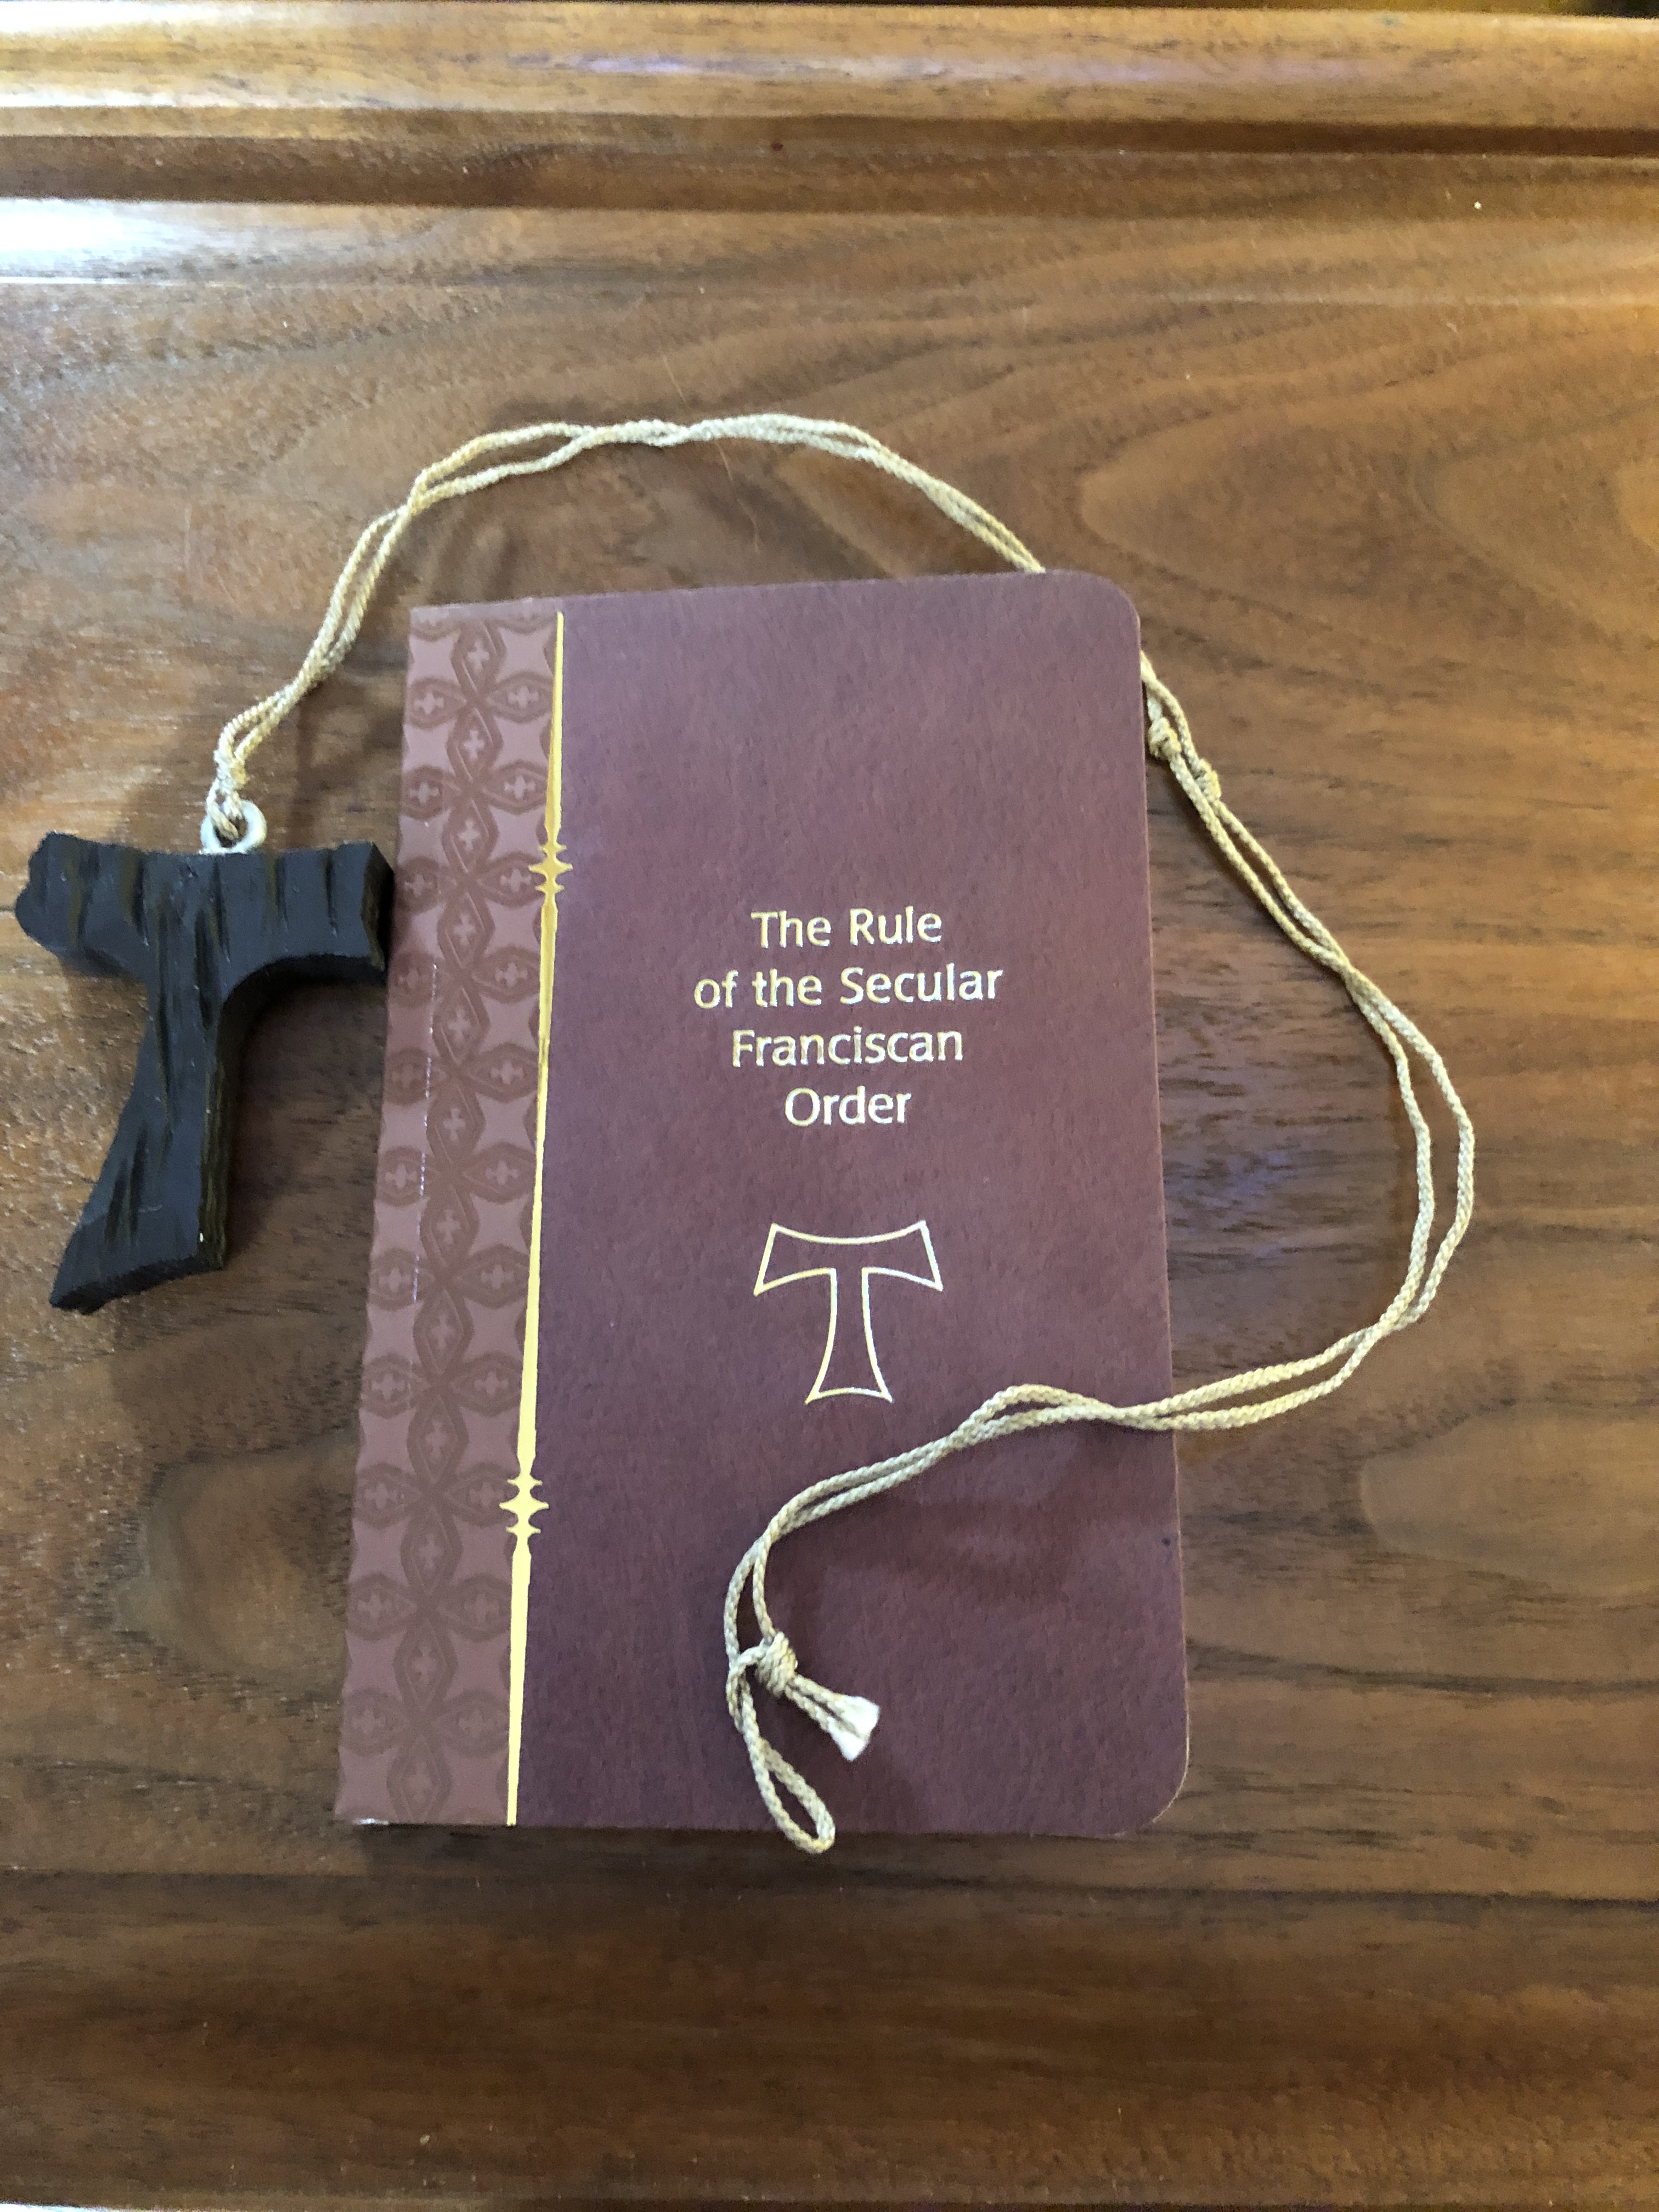
Minister p. 14

Candidate p. 14

Minister p. 14

Spiritual Assistant p. 15

The Whole Community p. 15

Applause

Presentation of the Rule of Life

Minister: (Director of Formation presents copy of the Rule) p. 15

Minister: (O.F.S. Member _________________________ presents TAU) p. 16

Spiritual Assistant introduces the Intercessions p. 16

Intercessions are provided (Reader 4: _________________________)

Spiritual Assistant concludes the Intercessions, Lord’s Prayer & Concluding Prayer p. 16

Minister p. 16

Sign of Peace (a suitable hymn is sung)

Blessing: Spiritual Assistant pp. 16 - 17

